- Blower Air Duster Black Cleaning
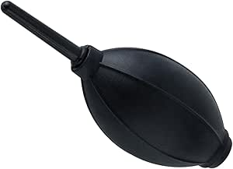

- SANYU Disposable Nitrile Gloves
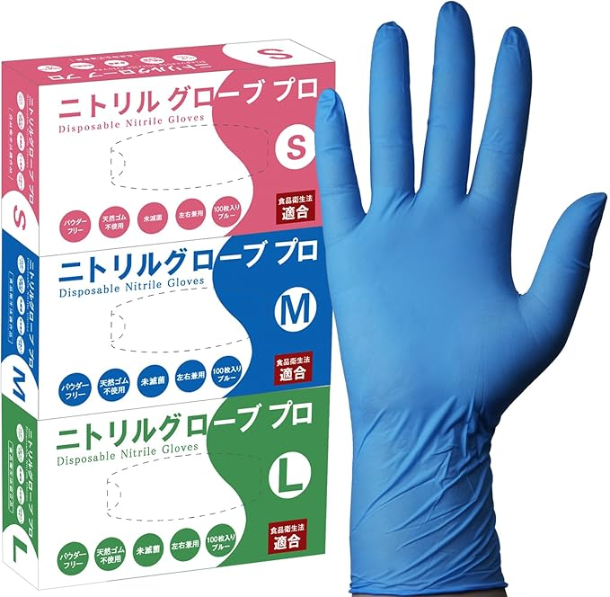

- Lint-free cloth
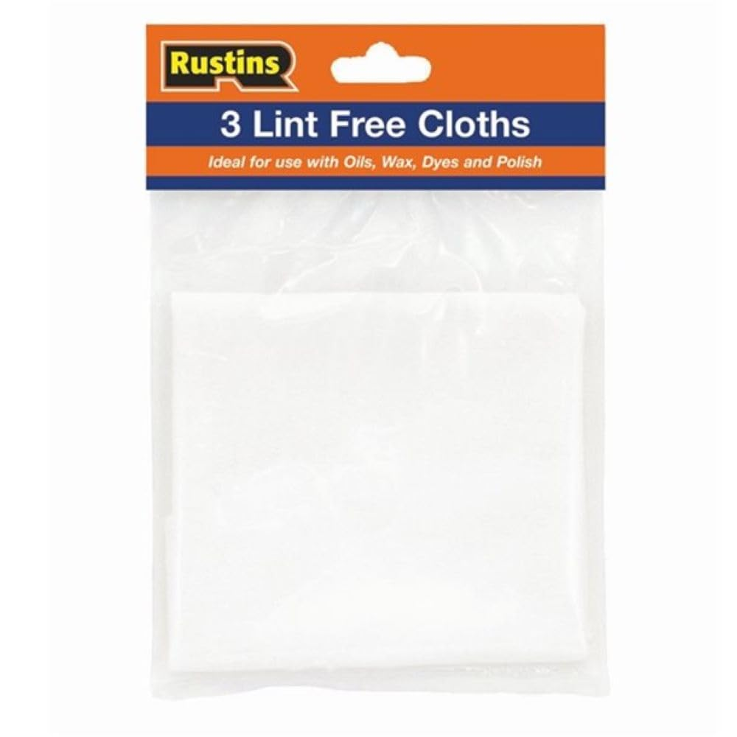

- 99% IPA (Isopropyl Alcohol Alcohol)
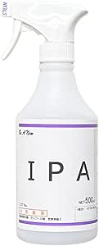

- Electrical Wiring Connector
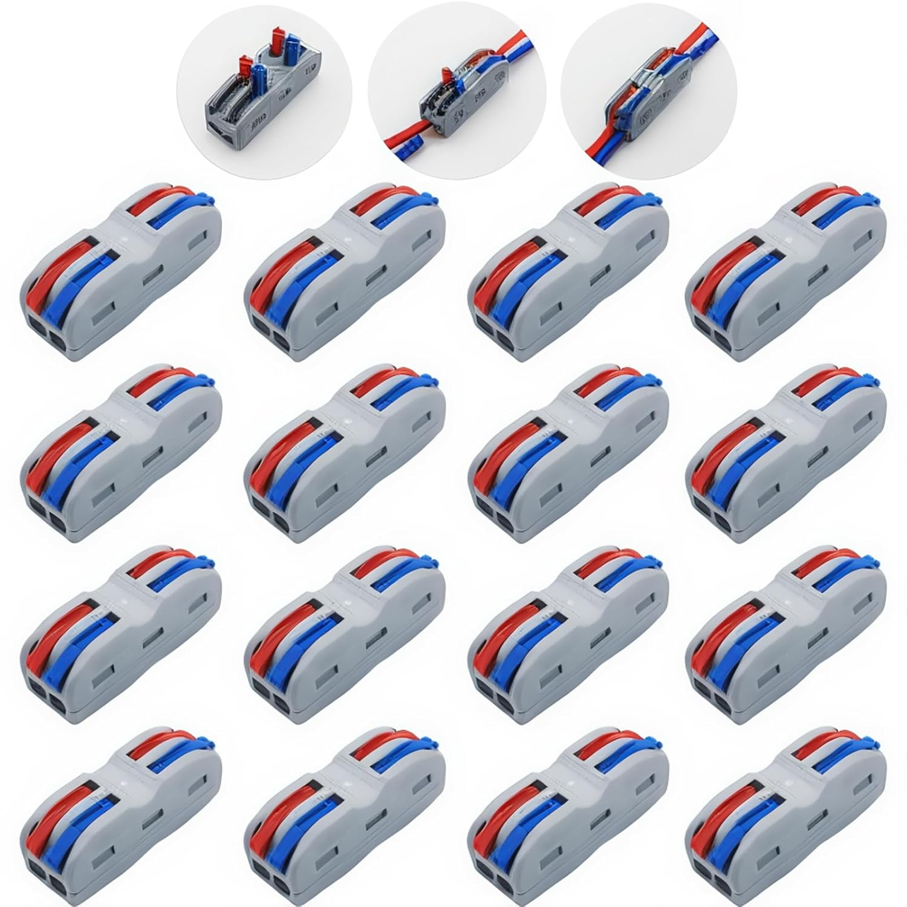
- Toolbox
